DATA STRUCTURE AND ALGORITHM
Name: Lorenzo M. Bautista Prof: Ma’am Gloria Dela Cruz
Section: BSIT 104 Date: March 25, 2026

LABORATORY 1
Code:
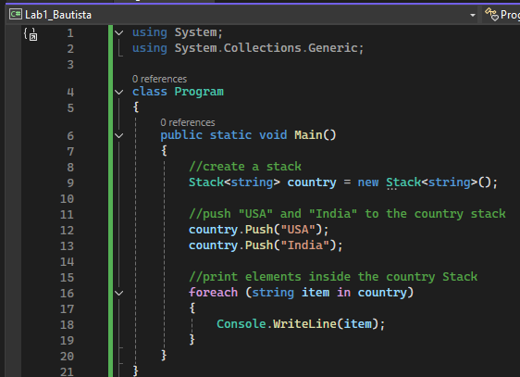
Output:
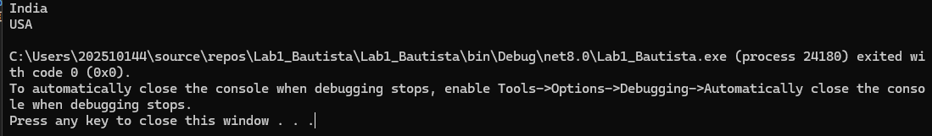

Code:
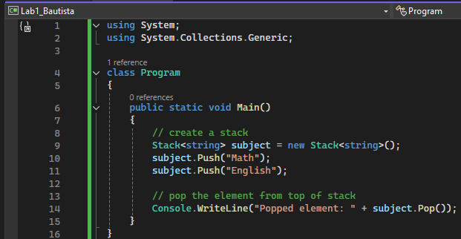
Output:
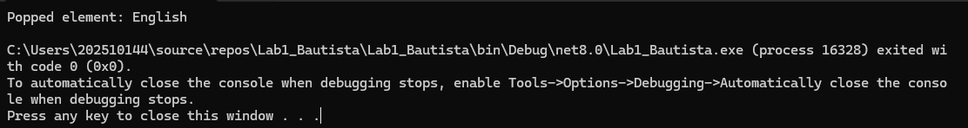

Code:
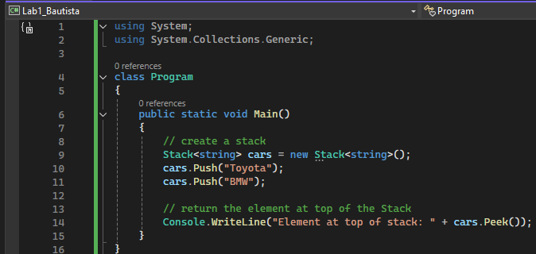
Output:
